# **Customer Care Email Survey (Medallia, myCustomer Connection)**

Reminders

Filtering for Desired Data

Detractors, Passives and Promoters

Net Promoter Score (NPS) Score Calculation

Overall Satisfaction (OSAT)

Key Metrics Overview

OSAT By Call Reason

PBM Feedback Page

Related Documents

**Description:** Explains member survey scores including the detractors, passives and promoters including how they are calculated using Medallia. In addition, it provides options for how to display certain data in these reports.

|  |
| --- |
| **Reminders** |

* Net Promoter Score (NPS) and Overall Satisfaction (OSAT) are separate questions rated by our members. Members may or may not rate them the same.
* Members answering these questions will respond based on their OVERALL experience with Caremark, not necessarily their latest experience with the Customer Care Representative (CCR). This is understood by leadership and considered as relates to an agent’s performance.
* OSAT and NPS (and the other specific questions the member responds to) are calculated differently. See the section below that corresponds to the score you are viewing for more information.

Top of the Document

|  |
| --- |
| **Filtering for Desired Data** |

Used when filtering information to display the data needed:

|  |  |
| --- | --- |
| **Search Option** | **Description and Illustration** |
| Search by Time Period | Click on the Time Period **drop down**, make selection as needed then select **Run**. |
| Subscription settings  (Metrics for notifications that display above or below a score) | Select the **bell** icon. |
| Export a Report | Select the **3 dots** adjacent to the bell icon.    **Result:**  Option to export to PDF, PowerPoint, Image or Excel displays. Make the selection. |
| Key Metric Overtime | **Note:** This automatically defaults to a table.  **Graph view:** Select the line tab.  **Bar graph view:** Select the column tab. |

Top of the Document

|  |
| --- |
| **Detractors, Passives and Promoters** |

Net Promoter Score (NPS) Measure of the relationship CVS Caremark has with its members, patients, and clients. NPS is based on the academic work of Fred Reichheld and has become a widely used metric across industries as a proxy for gauging the customer’s overall satisfaction with a company’s product or service and the customer’s loyalty to the brand.

It is a segmentation of customers into one of three groups:

* Promoters
* Passives
* Detractors

This is based on the member’s answer to the question, “How likely are you to recommend CVS Caremark to a friend or family member?”

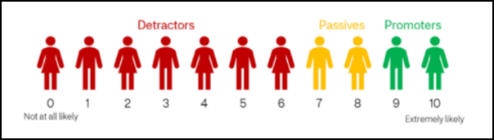

|  |  |
| --- | --- |
| **Term** | **Explanation** |
| **Detractors** | Gave a score lower or equal to 6.  They are not particularly thrilled by the product or the service. They, with all likelihood, will not purchase from the company again and could potentially damage the company’s brand reputation through negative word of mouth. |
| **Passives** | Gave a score of 7 or 8.  They are somewhat satisfied but could easily switch to a competitor’s offering if given the opportunity. They probably would not spread any negative word of mouth but are not enthusiastic. |
| **Promoters** | Gave a score of 9 or 10.  They love the company’s products and services. They are the repeat buyers, are the enthusiastic evangelist who recommends the company’s products and services to others. |

Top of the Document

|  |
| --- |
| **Net Promoter Score (NPS) Score Calculation** |

It is calculated by:

* Percent (%) of Promoters
* Minus
* Percent (%) of Detractors
* Equals (=) a number between -100 and 100.

**Note:** A negative NPS indicates more Detractors than Promoters, while a positive NPS indicates more Promoters.

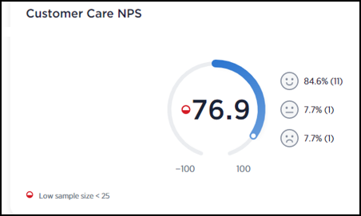

**Example:** In the screenshot above, the agent’s overall NPS score is 76.9. To the right of the overall NPS score, there are three smiley face icons.

* First or top is the **Promoters** score (84.6)
* Second icon is the **Passive** score (7.7)
* Third score is **Detractors** (7.7)

The Promoter score of 84.6% subtracted by the Detractor score of 7.7% equals the NPS score of 76.9. (84.6-7.7= 76.9)

The **Passive** score is dropped and not used in the calculation as they are “neutral.”

In the Main Customer Care page of Medallia, a table of recent surveys displays that have been returned by our members. This table displays Promoters in green, Passives in yellow, and Detractors in red.

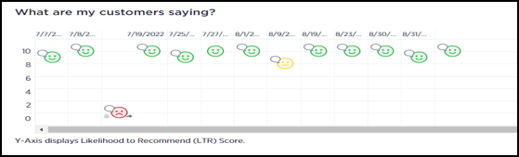

|  |  |
| --- | --- |
| **Smiley Icon color** | **Defined** |
| Green | Promoters (gave score between 9-10). |
| Yellow | Passives (gave score between 7-8). |
| Red | Detractors (gave score lower or equal to 6). |

**What are my customers saying?**

Hovercursor over smiley icon to view general member information including the member’s first and last name, date of survey with Pacific Standard Time (PST) time stamp.

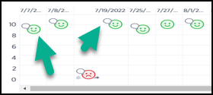

**Note:** If a thought bubble displays next to the smiley icon, hover the cursor on the smiley icon to review any comments left by member.

**Results:** Member Information and comments display.

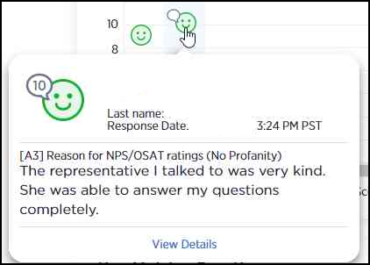

Top of the Document

|  |
| --- |
| **Overall Satisfaction (OSAT)** |

Overall Satisfaction is a separate question from Net Promoter Score. This question asks the member what their overall satisfaction with their experience with Caremark is/has been.

**Note:** For this question, the member is not being asked what their experience specifically with the Customer Care Representative was, but their overall satisfaction with Caremark as a whole. However, the CCR is usually the most recent interaction the member has had, and **how** you serve the member can greatly impact the scoring of this question.

With OSAT a score of 9 or 10 (Top 2 box, or the top two highest scores) is considered a “passing” score, where any score 0-8 is “not passing.” Average OSAT is calculated as the number of “passing” surveys, divided by the total number of surveys received for that Time Period (for instance 1 month).

100 surveys received, 90 out of 100 surveys were scored a 9 or 10 out of 10.

**Example:** 90/100= 90%

The Customer Care OSAT box displays the percentage of OSAT based on this calculation for all agents in the selected search group.

**Note:** CCRs will see only their own survey data.

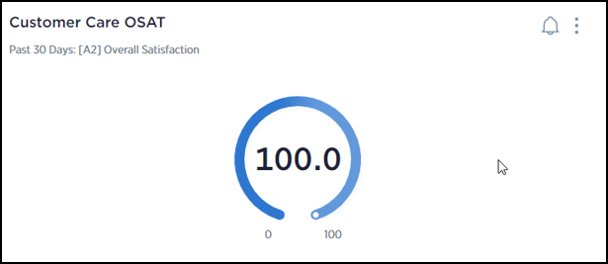

The OSAT by team member box will show the “sample size” or total number of surveys, as well as the percent of OSAT.

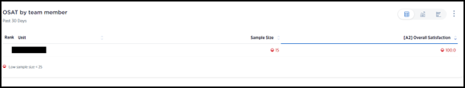

Top of the Document

|  |
| --- |
| **Key Metrics Overview** |

Displays the average scores of surveys within each category as well as number of surveys. This is vital information as it can be used to identify what areas are improving, maintaining, or need improvement.

|  |  |
| --- | --- |
| **Abbreviation** | **Meaning** |
| A1 | Customer Care Net Promoter Score (NPS) |
| A2 | Overall Satisfaction (OSAT) |
| B3 | Amount of time to reach a representative |
| C1 | Representative Attributes   * Showing care and concern * Speaking clearly and using understandable language * Ability to answer your questions * Providing useful information * Understanding your question or issue |

**Note:** Each of these specific questions are calculated the same way OSAT is, total top 2 box surveys (scores of 9 and 10) divided by total of all surveys in that period.

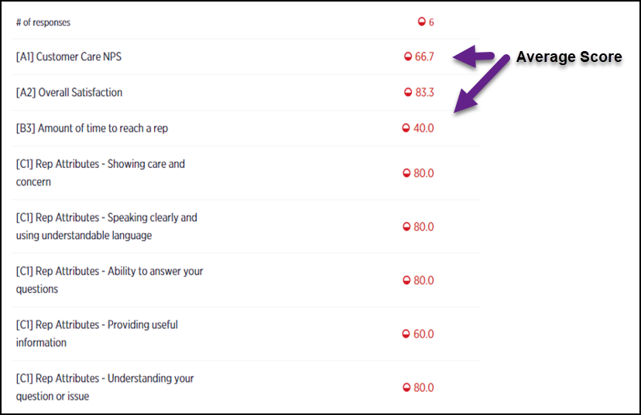

**Opportunity for Improvement**: In the 5th C1 (Rep Attributes – Providing Useful information) category, the agent had an average of 60.0. This shows on average, there are only 60% of members who feel strongly (scored 9 or 10 out of 10) useful information was provided, and this agent could consider ways to provide useful information for various callers or educate on **how** this information is useful to them (Caremark.com, drug alternatives, MChoice, Automatic Refills Program, etcetera.).

Top of the Document

|  |
| --- |
| **OSAT By Call Reason** |

These sections provide the OSAT (Overall Satisfaction) ratings of members for the Time Period and agent/agents selected based specifically on the members’ selections of the reasons they called.

**Example:**

Below is an image of average number of responses with the average score for each category.

* Level 1* is a high-level category (broader view of types of calls)
* Level 2* is a detailed view (more specific view of types of calls)

**Note:** In each of these graphs, you may click the options in the top right to switch between graph view and metric view.



|  |  |
| --- | --- |
| **Level 1** | **Level 2** |
| Includes OSAT percentage for more broad primary reasons for the calls:  **Example:** The lowest OSAT score for call type (less specific) was for Problem with an existing order. This helps us identity there are opportunities to look for with Order Status type calls. | Includes OSAT percentage for more specific breakdown of the primary reasons for the calls:  **Example:** We can see more specific areas where members were more, and less, satisfied. For instance, 100% of members gave a 9 or 10 score for “Register/sign up to automatic refills.” Only 61.7% of members gave a 9 or 10 score for “Discuss a prior authorization required by your prescription drug plan.” |
| **Level 1** | **Level 2** |
| This chart breaks down the percentage of call types that came in as chosen by the member.  In this example, we can see that most members called for “Ordering prescriptions/checking order status” (24.2%) or “Drug costs, coverage or approvals” (24.2%). Where only 3.6% of members called for “Web or account support, ID Cards.” This shows we can make an impact on more members by doing a great job supporting members on their refills, order status calls, and drug cost, coverage and approval calls. | This chart breaks down more detailed percentages of the reason members stated they called. In this case, “Other” was the most selected option. This could be many reasons, so the CCR might start with another category, such as “Place an order for refill or renewal” (9.0%), or “Find your out-of-pocket cost or copay for a specific drug.”  With 8.3% of members stating they are calling about drug costs, one opportunity may be to educate on the Price Estimate tool on Caremark.com or the Caremark app. This is a helpful option/solution for members to prevent the need to call as well as help them check drug costs while still in the Dr. office!  **Note:** Currently Medallia compresses the data, and it may overlap as above, remember you can switch to metric view. |
| This chart shows how many times the member stated they called about this same issue/concern. Think about if YOU had to keep calling back for an issue was still unresolved.  How would you feel about that experience and the company you were attempting to work with? How would that impact your survey choices if you were to complete a survey? | This chart shows how many members stated they did or did not attempt to resolve their request or have their question answered another way (rather than calling us).  With such a high percentage of members stating they did **not** attempt another way, this may indicate a great opportunity to educate on plan benefits, such as using Caremark.com to order prescriptions, check drug costs, file paper claims, etcetera to prevent them needing to call us. |
| This chart shows the OSAT (Overall Satisfaction) of members based on the number of times they called. Members shared that the more times they called (up to 5 times!), the less satisfied they were with their experience. You would likely feel the same way if you had to keep calling back! | This chart shows the OSAT (Overall Satisfaction) of members based on if they did or did not attempt to have their request/question resolved another way. Since members that DID attempt other resolution before calling us have a lower OSAT percentage in this example, this may indicate an opportunity to help members better understand how to use the tools and plan options available to them.  For instance; educating members on where to find tools in Caremark.com (profile link at the very top of the website for instance for Family Access and updating Credit Cards), understanding Maintenance Choice and the cost savings in getting a 90DS at a CVS or Mail Order, etcetera. |

Top of the Document

|  |
| --- |
| **PBM Feedback Page** |

Navigating to the PBM Feedback page (very top of Medallia) will enable you to take a more specific look at the member surveys.



Scrolling down, you can see the responses for individual surveys completed by the members. This will display the NPS score, the OSAT score, and additional information, including any specific verbatim comments the member shared about their experience (if they left one).

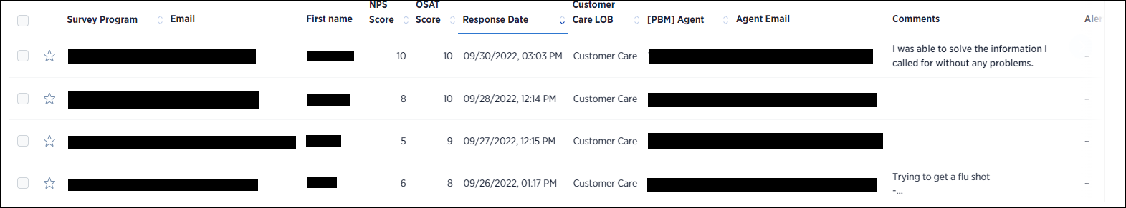

As you can see in this example, members may give a different score for NPS (Net Promoter Score) than for OSAT (Overall Satisfaction). For these surveys, the members have shared that their overall satisfaction with CVS/Caremark was higher than their willingness to recommend CVS/Caremark to their friends and family.

To view a specific survey in more detail, you can click the line for that individual survey and a hand will appear to choose that survey:



This displays the survey details:

**Note:** Scroll down to view this information. The information at the top is the member and survey specific information, not how and why the member answered each question.

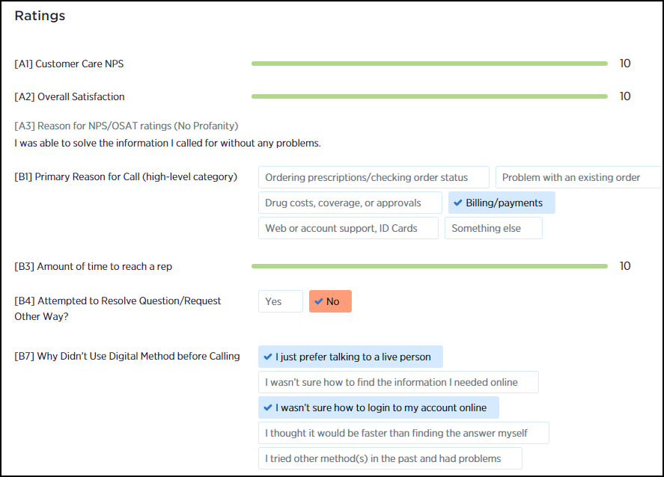

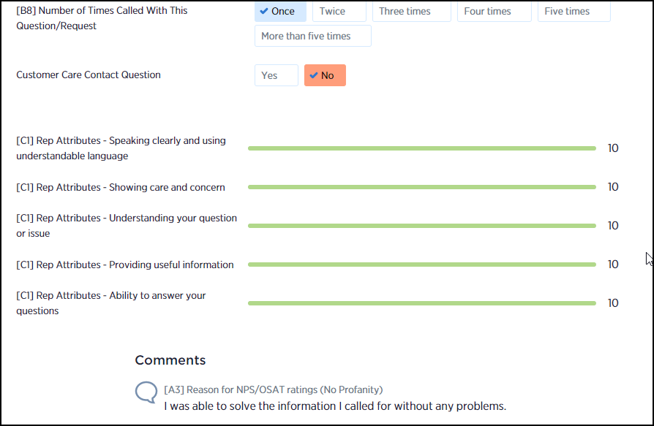

**Reminders:**

* NPS and OSAT are not agent specific and ask about the members’ experiences with CVS/Caremark.
* Scores and member comments may reflect things that are not agent related, such as: Frustration at the CTI/IVR System, frustration at the amount of time it took for the medication to arrive (especially around the holidays), etcetera. You can have a great impact on member experience by educating the member on clear expectations, such as Turnaround times, providing updated and accurate information (test claims, current PA status, etcetera), providing helpful information to empower the member (Plan Design benefits, Caremark.com, etcetera.) and by empathizing and reassuring the member.
* When we serve our members with compassion and care, they are more likely to be understanding when delays and other frustrations happen.

Top of the Document

|  |
| --- |
| **Related Documents** |

[Customer Care Abbreviations, Definitions, and Terms Index (017428)](C:\\Users\\DDavis6\\Desktop\\Subcommittee Review\\Template\\CMS-2-017428)

[Medallia (MyCustomer Connection) Log In Procedures (053325)](https://thesource.cvshealth.com/nuxeo/thesource/" \l "!/view?docid=761cdbd4-bd1e-4c01-92be-23e049f534ae)

Top of the Document

Not to Be Reproduced or Disclosed to Others without Prior Written Approval

**ELECTRONIC DATA = OFFICIAL VERSION / PAPER COPY = INFORMATIONAL ONLY**